Discussions for this week
Discussion question: Time to get your hands dirty!
Download the dataset Diabetes.xls from MyCourses.
This dataset looks at the incidence of diabetes in Pima Indian women.
The class variable is binary (whether or not the individual has diabetes).
Choose one of the attributes and report its descriptive statistics.

Then choose another attribute and compare the two together.

Discuss your findings and observations about this dataset.

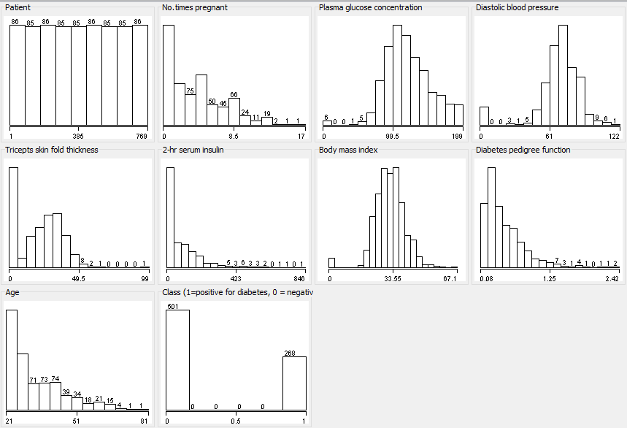

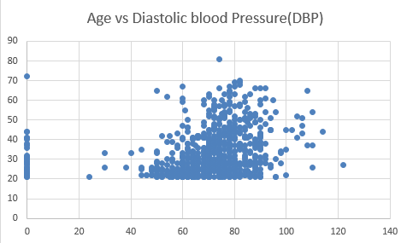
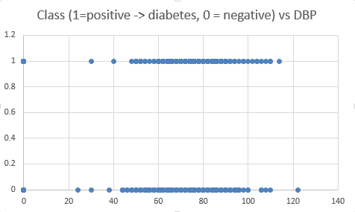
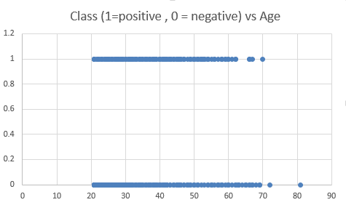
®
Using the data from both attributes and comparing them, we can come to the following conclusion. Majority of the patents between 45 and 80 years old had a DBP higher than 44, with the exception of only one patent.
The second attribute I chose is “Diastolic Blood Pressure (DBP),” and based on the dataset, most of the patients that tested positive for diabetics had a DBP higher than 40. And, only three patents that tested positive had their DBP below 40.
The first attribute I chose is “Age,” and based on the dataset, most patents between 20 and 62 years old tested positive for diabetics. And, only three out of patients between 63 and 80 years old tested positive for diabetics.

=== Run information ===

Scheme:weka.clusterers.EM -I 100 -N -1 -M 1.0E-6 -S 100
Relation: Diabetes
Instances: 769
Attributes: 10
Patient
No.times pregnant
Plasma glucose concentration
Diastolic blood pressure
Tricepts skin fold thickness
2-hr serum insulin
Body mass index
Diabetes pedigree function
Age
Class (1=positive for diabetes, 0 = negative)
Test mode:evaluate on training data

=== Model and evaluation on training set ===

EM
==

Number of clusters selected by cross validation: 9

Cluster
Attribute 0 1 2 3 4 5 6 7 8
(0.38) (0.05) (0.08) (0.04) (0.12) (0.1) (0.05) (0.14) (0.05)
=================================================================================================================================
Patient
mean 415.7661 486.2607 618.8519 132.189 301.4505 206.3573 120.5605 494.3622 402.001
std. dev. 207.889 204.4178 114.6232 92.8146 180.0483 147.1446 88.8221 165.469 236.9402

No.times pregnant
mean 1.9927 2.2905 6.6583 2.0028 2.6317 7.3671 6.8164 6.1324 2.8003
std. dev. 1.7108 2.2638 3.5924 1.4879 2.4511 3.2473 2.5472 3.4061 2.7753

Plasma glucose concentration
mean 109.5228 169.5168 134.4369 92.2348 132.2842 147.1648 112.9231 115.2957 97.6387
std. dev. 21.3627 19.9541 37.9059 37.1436 25.1366 29.7823 26.9866 29.5322 23.2707

Diastolic blood pressure
mean 68.4446 75.6885 75.2572 64.2561 62.5437 77.7578 76.9545 76.2371 28.0511
std. dev. 10.9116 11.3866 17.2124 10.6264 27.8112 10.2903 8.622 13.4872 36.0166

Tricepts skin fold thickness
mean 25.3091 33.7822 21.0465 14.8397 20.9775 20.0576 15.1098 12.1356 2.5235
std. dev. 11.9369 11.6619 19.4985 11.7925 17.7279 16.3411 16.6375 15.5341 6.6245

2-hr serum insulin
mean 95.7707 286.8314 46.2811 26.3514 66.7561 122.3452 32.6281 18.7216 1.763
std. dev. 94.9632 203.177 76.1426 36.238 80.5171 158.314 59.679 41.0079 8.4652

Body mass index
mean 31.5342 38.2911 33.9927 27.2416 36.7099 33.6012 31.7409 29.7952 20.2186
std. dev. 6.7863 6.7181 5.4108 5.0732 7.7369 6.7129 6.4491 6.4662 12.6178

Diabetes pedigree function
mean 0.4548 0.7981 0.4564 0.3421 0.5756 0.5393 0.4275 0.3722 0.3206
std. dev. 0.2957 0.5907 0.2753 0.1642 0.3769 0.3165 0.2932 0.2503 0.2044

Age
mean 25.5662 32.8136 44.411 23.9849 28.777 44.8056 44.1506 44.4594 26.0479
std. dev. 4.5077 10.1413 9.0078 2.9216 4.8727 9.2261 9.7216 13.1012 5.4421

Class (1=positive for diabetes, 0 = negative)
mean 0 0.8286 0.9898 0.1037 1 1 0.0087 0 0.0955
std. dev. 0.4768 0.3768 0.1006 0.3049 0.4768 0.0006 0.0931 0.4768 0.2939

Time taken to build model (full training data) : 23.63 seconds

=== Model and evaluation on training set ===

Clustered Instances

0 240 ( 31%)
1 32 ( 4%)
2 28 ( 4%)
3 45 ( 6%)
4 21 ( 3%)
5 195 ( 25%)
6 51 ( 7%)
7 88 ( 11%)
8 69 ( 9%)

Log likelihood: -34.35549

The use of the World Wide Web is increasing continuously, which makes it very helpful to use as a source for prediction purpose. The topic in which I want to implement some models and strategies, contained in the papers cited below, is Big Data Medical Diagnosis. This is the main reason why I chose “session 6. WSDM 2013: Rome, Italy”, where I found the topics that best fit my topic of interest based on web mining, prediction and recommendation.
The requirement for predicting the symptoms of users would be defined as any action that adapts the information and or services provided by a database to the need of a particular user. Therefore, this database would be taking advantage of the knowledge gained from navigational of the user. Moreover, implementation strategies such as symptoms diagnosis, diagnosis popularity, and diagnosis performance could be applied on a database that is only based on medical sources. These strategies were derived by me from the implementation models and techniques used in the papers cited below.
This project has been a topic I have been interested the last months, and one of the biggest reason to why I am currently taking this class. The development of each one of these strategies as one could allow us to build a hybrid system for a better diagnosis. However, the data recorded in medical databases is often sparse and collected with no concerted e
ort to maintain data quality. This could seriously harm the system performance, keeping from becoming smarter from the users feedback. In order to avoid sparse data, a good cleaning process and preparation of the data must be performed. For this process, I am using as a reference research papers such as "Discover of Temporal Patterns in Sparse Course-of Disease Data," "Data Quality in Genome Databases," and "Exploration Mining in Diabetic Patients Findings and Conclusions." These research papers, the last three papers cited below, use di
erent cleaning techniques to prepare the data to understand the overall process of knowledge discovery in a medical database environment. This type of system would allow us to predict diagnosis of symptoms that currently afflict users, and also give them recommendations based on their, or other users, prior similar symptoms. As a result, this would contribute to the implementation of a personalized system that would allow users to rank accurate symptoms diagnosis accordingly as well as to diagnose other users with similar symptoms.

REFERENCES
[1] Henrique Pinto, Jussara M. Almeida, and Marcos
Andre Goncalves: \Using early view patterns to predict
the popularity of youtube videos." 365-374.
[2] Kira Radinsky, Paul N. Bennett: "Predicting content
change on the web." 415-424.
[3] Marios Kokkodis, Panagiotis G. Ipeirotis: \Have you
done anything like that?: predicting performance using
intercategory reputation." 435-444.
[4] Jorge C. G. Ramirez1,2, Lynn L. Peterson1, Diane J.
Cook1, Dolores M. Peterson2: \Discovery of Temporal
Patterns in Sparse Course-of-Disease Data."
Department of Computer Science and Engineering
University of Texas at Arlington 1-23.
[5] Heiko M~ Aijller, Felix Naumann, Johann-Christoph
Freytag: \DATA QUALITY IN GENOME
DATABASES." Humboldt University Berlin, Germany
1-16.
[6] Wynne Hsu, Mong Li Lee, Bing Liu, Tok Wang Ling:
\Exploration Mining in Diabetic Patients Databases:
Findings and Conclusions." School of Computing
National University of Singapore 1-7.

First Paper

Medical Data mining is the process of extorting hidden patterns from medical data. We propose the work which presents the development of clustering techniques for classifying Pima Indian diabetic database (PIDD). Here, clustering algorithm is used for predicting diabetic disease based on graph b-colouring technique. The proposed technique presents a real representation of clusters by dominant objects that assures the inter cluster disparity in a partitioning and used to evaluate the quality of cluster

In this work, a colouring method, namely b-colouring, well-adapted for clustering is proposed. The b-colouring is defined as follows: Let G=(V,E) [1] be an undirected connected and simple graph with vertex set V and edge set E. the b-colouring of G is a vertex colouring function c from V to the set of colours {1,2,3,…k} such that: For each pair of adjacent vertices (vi,vj)єE, c(vi) c(vj)(proper colouring) In each colour class, there exists at least one vertex having neighbors in all other colours classes. Such a vertex is called a dominating vertex. It allows building a fine partition of the data set where the number of clusters is not set in advance. In fact, the purpose of this approach is to use dissimilarities between all objects to find a partition of the data set in clusters where the cluster separation is achieved simultaneously with the cluster consistency. This approach exhibits two important features it is robust in the presence of outliers and it 521 identifies each cluster by at least one dominant object which guarantees the disparity between clusters. Data analysis motivates many computing applications, either in a planning phase or as part of their on-line operations. Analysis of data is a process of examining, cleaning, transforming, and modeling data with the goal of emphasizing useful information, providing conclusion, and giving correct decision making. The paper is organized as follows: In Section II, Clustering and its importance was discussed. In Section III, diabetes and its classification were discussed. In Section IV, Algorithms for Classifying the Pima Indian diabetic dataset was analyzed. Applications of b-colouring technique in clustering were discussed in Section V. Section VI deals with experimental analysis. Finally the conclusion was given in Section VII.

The Pima Indian diabetes database, donated by Vincent Sigillito, is a collection of medical diagnostic reports of 768 examples from a population living near Phoenix, Arizona, USA. The paper dealing with this data base [15] uses an adaptive learning routine that generates and executes digital analogs of perceptron-like devices, called ADAP. They used 576 training instances and obtained a classification of 76% on the remaining 192 instances. The samples consist of examples with 8 attribute values and one of the two possible outcomes, namely whether the patient is tested positive for diabetes (indicated by output one) or not (indicated by two). The database now available in the repository has 512 examples in the training set and 256 examples in the test set. The attribute vectors of these examples are in Table1.

The clustering based on the b-colouring of a graph is used for clustering Pima Indian diabetic dataset. Consider the data to be clustered as an undirected edge-weighted graph with no self-loops G = (V, E), where V = {v1,...,vn} is the vertex set and E = V ×V is the edge set. Vertices in G correspond to objects, edges represent neighborhood relationships, and edge-weights reflect dissimilarity between pairs of linked vertices. The graph G is traditionally represented with the corresponding weighted dissimilarity matrix, which is the n × n symmetric matrix D={di,j| vi,vj∈ V}. A common informal definition states that “a cluster is a set of entities which are similar, and entities from different clusters are not similar”. Hence, a cluster should satisfy two fundamental conditions: (1) it should have high internal homogeneity; (2) there should be high heterogeneity between entities within one cluster and those from other clusters.

SECOND PAPER

Diagnosis of the Pima Indian diabetes disease using multilayer neural network

In the first stage of this study, a multilayer neural network structure which was trained by Levenberg–Marquardt (LM) algorithm was used for the pima-diabetes disease diagnosis. The network structure used for this purpose is shown in Fig. 1. This network was the multilayer network (input layer, hidden layers, and output layer). The hidden layer neurons (50 neuron for each hidden layer) and the output layer neurons use nonlinear sigmoid activation functions. In this system, eight inputs were features, and two outputs are index of two classes. Equations used in the neural network model are shown in (1)–(3).

where Wih1(n) are the weights from the input to the first hidden layer and ~bih1ðnÞ are the biases of the first hidden layer, Wih2(n) are the weights from the first hidden layer to the second hidden layer and ~bih2ðnÞ are the biases of the second hidden layer, Who(n) the weights from the second hidden layer to the output layer and are the biases of the output layer, ~f ðnÞ values the features, values the outputs for the class index, and on a training pattern index.

Levenberg–Marquardt algorithm (Hagan & Menhaj, 1994) was used in this study for the training of the multilayer neural network structure. Detailed computational issues about the application of the training algorithm to MLNN can be found in Gulbagand Temurtas (2006), Matlab documentation (2004).

2.4. Diagnosis of the Pima Indian diabetes disease using probabilistic neural network
At the second stage of this study, a probabilistic neural network was used for the pima-diabetes disease diagnosis. The network structure used for this purpose is shown in Fig. 2.

The PNN structure used in this study has a multilayer structures consisting of a single hidden layer (radial basis layer) of locally tuned units which are fully interconnected to an output layer (competitive layer) of two units, as shown in Fig. 2. In this system, real valued input vector is feature’s vector, and two outputs are index of two classes. All hidden units simultaneously receive the eight-dimensional real valued input vector. The input vector to the network is passed to the hidden layer nodes via unit connection weights. The hidden layer consists of a set of radial basis functions.

Associated with jth hidden unit is a parameter vector, called a center. The hidden layer node calculates the Euclidean distance between the center and the network input vector and then passes the result to the radial basis function. All the radial basis functions are the same type (Gaussian).

Equations which used in the neural network model are shown in (4)–(8).

where i = 1,2, j = 1,2,. . . ,h, Yi is the ith output (classification index), the eight-dimensional real valued input vector, What the weight between the jth hidden node and the ith output node, the center vector of the jth hidden node, is the real constant known as spread factor, the biasing term of radial basis layer, and /(_) the nonlinear radial basis function (Gaussian).

The PNN structures employed in the study utilized the new pnn function implemented in MATLAB. Detailed information about the realization of the PNN structures can be found in the neural network toolbox part of MATLAB Documentation (Matlab documentation,
2004).

This paper presents a comparative study on Pima Indian diabetes disease diagnostic by using multilayer neural network which was trained by LM algorithm and probabilistic neural network.
The results were also compared with the results of the pervious studies reported (Carpenter & Markuzon, 1998; Deng & Kasabov, 2001; Kayaer & Yıldırım, 2003; Polat & Gunes, 2007; Polat et al., 2008) focusing on pima-diabetes disease diagnosis and using the same database.

As the conclusion, the following results can be summarized:
_ It was seen that neural network structures could be successfully used to help diagnosis of pima-diabetes disease.
_ the classification accuracy of MLNN with LM obtained by this study using correct training was better than those obtained by other studies for the conventional validation method.
_ for the 10-fold cross-validation method, the classification accuracy of MLNN with LM obtained by this study using correct training was a bit better than those obtained by other studies except the classification accuracies by Polat and Gunes (2007) which is not reproducible.
_ the results obtained using PNN structures are also quite good for Pima Indian diabetes disease diagnostic problem in comparison with the results obtained by the other studies especially for 10-fold cross-validation method.

Diabetes and Obesity in the Offspring of Pima Indian Women with Diabetes during Pregnancy

Figure 1—Prevalence of single and multiple congenital anomalies according to maternal diabetes status. Nondiabetic, mothers who remained nondiabetic (n = 2013); prediabetic, mothers who developed diabetes at some time after delivery (n = 511); diabetic, mothers who had diabetes as a complication of pregnancy (n = 114). Adapted from Bennett et al. (5).

Figure 3—Prevalence of obesity (>140% of standard weight for height) according to age at examination and maternal diabetes during pregnancy. For maternal diabetes during pregnancy relative to occurring after pregnancy, P < 0.001 adjusted for age, sex, and parental obesity. Adapted from Pettitt et al. (7).

Figure 4—Mean 2-h post-load plasma glucose concentration according to age at examination and maternal diabetes during pregnancy. Values are means ± 1 5E. (DM), offspring of diabetic women; (PreD), offspring of pre-diabetic women; (NonD), offspring of non-diabetic women. P < 0.001 for the effect of having a mother with diabetes during rather than only after pregnancy, adjusted for age and sex.

Figure 5—Prevalence of diabetes (2-h post-load plasma glucose concentration of >11.1 mM [200 mg/dl]) according to age at examination and maternal diabetes status. For maternal diabetes during pregnancy relative to occurring after pregnancy, P < 0.005, adjusted for age and sex. Adapted from Pettitt et al. (12).

Now go looking for research papers using this dataset. See if they do any analysis or cleaning on it. What are your thoughts about the papers you find?
After a very intensive online search, I was able to find a couple of research papers that used the Diabetes.xlsx dataset in their proposed implementation. Out of all research papers I only picked two, which are "An Approach for Prediction of Diabetic Disease by using b-Colouring Technique in Clustering Analysis," "A comparative study on diabetes disease diagnosis using neural networks," and "Diabetes and Obesity in the Offspring of Pima Indian Women with Diabetes during Pregnancy," and my thoughts about these are the following:
An Approach for Prediction of Diabetic Disease by Using b-Colouring Technique in Clustering Analysis
Description: This paper is based on the Diabetes dataset analysis. They used clustering techniques to classify the Pima Indian Database (PIDD). The method the used for clustering was the b-colouring with the purpose of using dissimilarities between every object to find a partition of the dataset in which the cluster separation and consistency is achieved. Their analysis of the data was a process of examining, cleaning, transforming and modeling the data to emphasize useful information and provide conclusion and correct decision making.
Thoughts: The use of clustering to classify the diabetes dataset seems to me a very good approach for this type of database. I have never heard of the b-colouring clustering technique, however I am familiar with this type in which they use color to distinguish different population(s) within a class. I was a little bit disappointed with the fact that they mention that they used an examining, cleaning and transforming process to make the data useful but they but they did not go into detail how the process took place, which would have been good for my understanding and putting the pieces together with what I have learned so far.

Comparative study on diabetes disease diagnosis using neural networks
Description: The approach used in this paper to analyze the diabetes dataset is more advanced than that explained above. In this paper they use a multilayer neural network structure for the Pima Diabetes disease diagnosis. This network is composed by an input layer, hidden layers, and output layer, a system in which eight input are features and two outputs are index of two classes. The interesting part is in the hidden layer, which calculates the Euclidean distance between the center and the input vector to transfer the result to a radial basis function. They made use of software tool such as MATLAB, and had their neural network trained by LM algorithm and probabilistic network.
Thoughts: I was impressed of the advanced algorithm that is being used in this paper for medical diagnosis. It actually gave me some ideas of how to implement neural network on a medical database for diagnosing purpose. Even though the algorithm seems somewhat complex, I still relate to it and to the important of the Euclidean technique to calculate the distance between the objects. Similar to the first paper, I was also disappointed with the fact that day do not explain how the cleaning process took place to prepare/model de data for the use of the neural network.

Diabetes and Obesity in the Offspring of Pima Indian Women with Diabetes during Pregnancy
Description: This paper focused on the use of exploration data techniques to examine and evaluate the data. The techniques they used are very similar to those used in class, and the way they explain the dataset and its results has a lot of correlation with the study we have been doing on the dataset.
Thoughts: I was happy that in this paper the cleaning process of the data is detailed explain. They made use of graphing techniques similar to those used in class, and explained the data according to the behavior observed in each one of these graphs.

Overall Thought: Each one of the paper help me to better understand the dataset and how to explore, examine, clean, and use the data for analysis purpose. It is important to highlight that each one the steps mention in these papers are important for the analysis of a dataset. I was able to see how they explore, examine, and mine the dataset to study its behavior and for mining purpose.
For a more detailed information about the research papers, based on the diabetes dataset, that I have chosen and the topics covered above, I have cited the journals below for reference purpose.

(Thilagavathi)
(Hasan Temurtas)
(DAVID J. PETTI-IT)

Works Cited
DAVID J. PETTI-IT, ROBERT G. NELSON, MOHAMMED F. SAAD, PETER H. BENNETT, and WILLIAM C. KNOWLER. "Diabetes and Obesity in the Offspring of Pima Indian Women With Diabetes During Pregnancy." DIABETES CARE, (1993): VOLUME 16, SUPPLEMENT 1. Pettitt and Associates.
Hasan Temurtas, Nejat Yumusak, and Feyzullah Temurtas,. "A comparative study on diabetes disease diagnosis using neural networks." Expert Systems with Applications (2009): 8610–8615. Dumlupinar University, Department of Electrical and Electronics Engineering, Kutahya, Turkey.
Thilagavathi, D. Vijayalakshmi and K. "An Approach for Prediction of Diabetic Disease by Using b-Colouring Technique in Clustering Analysis." International Journal of Applied Mathematical Research, (2012): 1 (4) 520-530. Science Publishing Corporation.

